
Yunnan University Software College Professional Training Report
School of Software, Yunnan University

Personal Grades
(Students fill in (except the last column))
Serial number | Student number | Name | Major | Score
1 | 20233120013 | Tuhin Md Abu Hamza | Software

Semester: Fall 2025 .
Course Name: Professional Training .
Teacher: Ahmed Zahir .
Project Name: Sentiment analysis .
Report completion Date: 2025/12/10 .

Table of Contents
Abstract 2
1. Introduction 3
1.1 Background & Motivation 3
1.2 Why Transformers and Vector Search 3
2. Literature Review 4
2.1 Sentiment Analysis Approaches 4
2.2 Transformer-Based Models for NLP 4
2.3 Sentence Embeddings and Semantic Search 5
2.4 Vector Databases and ChromaDB 5
3. System Design 5
3.1 Overall System Architecture 6
3.2 Docker Container Architecture 7
3.3 Data Preprocessing Workflow 7
3.4 Sentiment Analysis Pipeline (ML Pipeline) 8
3.5 Embedding Generation and Vector Storage 8
3.6 Semantic Search Workflow 9
4. Implementation 9
4.1 Data Preprocessing Implementation 9
4.2 Sentiment Analysis Model Implementation 10
4.3 Embedding Generation 10
4.4 Vector Database Integration 10
4.5 API and Frontend Communication 10
4.6 Dockerization and Deployment 11
4.7 Version Control and GitHub Repository 11
5. Results and Evaluation 11
5.1 Sentiment Analysis Results 11
5.2 Confidence Score Analysis 12
5.3 Semantic Search Evaluation 12
5.4 Performance Considerations 12
5.5 Overall Evaluation 13
6. Discussion 13
6.1 Challenges Faced During Implementation 13
6.2 Offline Model Execution and Reproducibility 13
6.3 Benefits of Docker-Based Deployment 14
6.4 Limitations of the System 14
6.5 Discussion Summary 14
7. Conclusion & Future Work 14
7.1 Future Work 15
REFERENCES 15

Abstract
Sentiment analysis is an important application of Natural Language Processing (NLP) that focuses on identifying opinions and emotions expressed in text. This project presents the design and implementation of a transformer-based sentiment analysis system with an additional semantic search capability. A pre-trained DistilBERT model is used to classify user-provided text into positive or negative sentiment classes.
To enhance analytical functionality, sentence embeddings are generated using a SentenceTransformer model and stored in a ChromaDB vector database. This allows the system to retrieve semantically similar past texts using similarity-based search rather than traditional keyword matching. The application is developed following a microservice architecture and is fully containerized using Docker Compose. It consists of a FastAPI backend for model inference, a Gradio-based frontend for user interaction, and a dedicated vector database service.
The system is designed to run in offline mode after initial model caching, ensuring reproducibility and stable deployment. Through this project, practical understanding of transformer models, vector databases, and containerized deployment of modern NLP systems is demonstrated.

1. Introduction

1.1 Background & Motivation
Sentiment analysis is a fundamental task in Natural Language Processing (NLP) that aims to determine the emotional polarity of text data, such as whether a sentence expresses positive or negative sentiment. It is widely used in real-world applications including customer feedback analysis, product review evaluation, and social media monitoring. Organizations rely on sentiment analysis systems to better understand user opinions and improve decision-making processes.
Earlier sentiment analysis methods mainly depended on rule-based techniques and traditional machine learning algorithms. Although these approaches produced acceptable results on limited datasets, they often failed to capture contextual meaning and long-range dependencies in language. As a result, their performance was limited when dealing with complex or ambiguous sentences.
Recent advances in deep learning have significantly improved sentiment analysis performance. In particular, transformer-based architectures have shown strong results by learning contextual representations of text using attention mechanisms.

1.2 Why Transformers and Vector Search
Transformer models such as BERT and its lightweight variant DistilBERT have become popular due to their ability to understand contextual relationships between words. DistilBERT achieves performance comparable to BERT while reducing model size and inference time, making it suitable for efficient deployment in practical applications [2][3].
In addition to sentiment classification, semantic search has gained importance in modern NLP systems. Unlike keyword-based search, semantic search uses vector embeddings to capture the meaning of text. By integrating a vector database, embeddings can be stored and retrieved based on similarity scores. This enables the system to find relevant past texts that are contextually similar to the user’s input, thereby improving analytical depth and user experience [4].

2. Literature Review

2.1 Sentiment Analysis Approaches
Sentiment analysis has been an active research area in Natural Language Processing for many years. Early approaches primarily relied on lexicon-based techniques, where predefined dictionaries of positive and negative words were used to determine sentiment polarity. While these methods were simple and interpretable, they were highly sensitive to domain changes and failed to capture contextual meaning.
Later, traditional machine learning models such as Naïve Bayes, Support Vector Machines (SVM), and Logistic Regression were introduced for sentiment classification. These models improved performance by learning from labeled data but still depended heavily on handcrafted features such as n-grams and term frequency–inverse document frequency (TF-IDF). As a result, they struggled with complex sentence structures and contextual dependencies.
The limitations of traditional approaches led to the adoption of deep learning models, which automatically learn feature representations from raw text. These models demonstrated improved accuracy and generalization, especially when large datasets became available.

2.2 Transformer-Based Models for NLP
The introduction of the transformer architecture marked a significant breakthrough in NLP research. Unlike recurrent neural networks, transformers rely on self-attention mechanisms to model relationships between words in a sentence, regardless of their position. This design allows transformers to efficiently capture long-range dependencies in text [1].
BERT (Bidirectional Encoder Representations from Transformers) further improved NLP performance by learning bidirectional contextual representations during pre-training. This enabled the model to understand both left and right context simultaneously, leading to strong performance across various NLP tasks, including sentiment analysis [2].
DistilBERT is a compressed version of BERT that retains most of its accuracy while significantly reducing model size and inference time. Due to its efficiency and strong performance, DistilBERT is widely used in real-world applications where computational resources are limited [3]. For this reason, DistilBERT was selected as the sentiment classification model in this project.

2.3 Sentence Embeddings and Semantic Search
Semantic search focuses on retrieving information based on meaning rather than exact keyword matches. This approach relies on dense vector representations, known as embeddings, which capture the semantic relationships between sentences. Sentence-BERT introduced an effective method for generating sentence-level embeddings using a Siamese network architecture based on transformer models [4].
By converting text into embeddings, similarity metrics such as cosine similarity can be used to identify semantically related sentences. This technique is particularly useful in applications such as information retrieval, recommendation systems, and question answering.
In recent years, vector databases have been developed to efficiently store and search large collections of embeddings. These databases support fast similarity search and are optimized for high-dimensional vector data.

2.4 Vector Databases and ChromaDB
Vector databases such as FAISS, Milvus, and ChromaDB are designed to handle large-scale embedding storage and similarity search. ChromaDB provides a lightweight and developer-friendly solution that integrates well with modern NLP pipelines.
ChromaDB supports storing text embeddings along with associated metadata, enabling advanced querying and filtering capabilities. Due to its simplicity, scalability, and compatibility with embedding-based NLP systems, ChromaDB was selected as the vector database for this project. It allows the system to store sentiment-related embeddings and retrieve relevant past texts using similarity-based search.

3. System Design
This section describes the complete system design of the proposed application. The design is explained progressively, starting from the overall architecture and then detailing individual components such as data preprocessing, sentiment inference, embedding generation, vector storage, and Docker-based deployment. The diagrams are presented in a logical order to clearly illustrate the workflow and interaction between system components.

3.1 Overall System Architecture

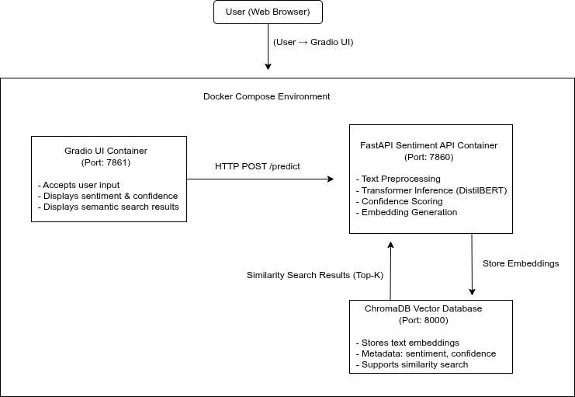
Figure 1: Overall System Architecture
Figure 1 illustrates the overall architecture of the proposed sentiment analysis and semantic search system. The user interacts with the application through a web browser using a Gradio-based user interface. The frontend is responsible only for collecting user input and displaying results, ensuring that no machine learning logic is handled at the UI level.
The Gradio UI communicates with the backend through HTTP REST requests. The backend is implemented using FastAPI and is responsible for handling inference requests. Upon receiving input text, the backend performs sentiment analysis using a transformer-based model and generates a prediction along with a confidence score.
In addition to sentiment inference, the backend also interacts with a vector database to store and retrieve text embeddings. The embeddings are stored in ChromaDB, which enables similarity-based semantic search. All services are deployed as separate Docker containers and communicate through an internal Docker network.

3.2 Docker Container Architecture
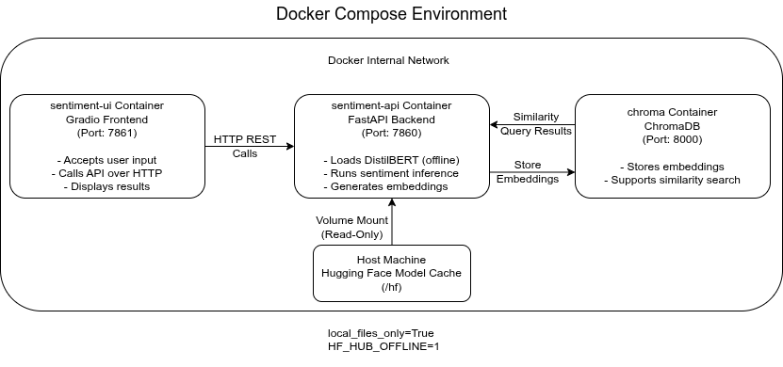
Figure 2: Docker Container Architecture
Figure 2 illustrates the Docker-based deployment architecture of the application. The system is deployed using Docker Compose and consists of three independent containers: a FastAPI container for sentiment inference, a Gradio UI container for frontend interaction, and a ChromaDB container for vector database operations.
Each container runs as an isolated service with a clearly defined responsibility. The FastAPI container exposes a REST endpoint for sentiment prediction, while the Gradio container provides a web-based interface for user interaction. The ChromaDB container manages embedding storage and similarity search functionality.
To support offline execution, the Hugging Face model cache is mounted as a read-only volume inside the containers. All containers communicate with each other through a shared Docker network, ensuring secure and efficient inter-service communication.

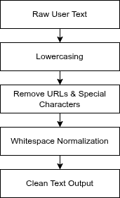
3.3 Data Preprocessing Workflow
Figure 3 shows the text preprocessing steps applied to raw user input before model inference. The preprocessing pipeline includes converting text to lowercase, removing URLs and special characters, and normalizing whitespace. These steps help reduce noise in the input data and improve the quality of model predictions.
The output of this stage is a clean and normalized text string, which is then passed to the tokenization and inference stages of the pipeline.

Figure 3: Data Preprocessing Workflow

3.4 Sentiment Analysis Pipeline (ML Pipeline)
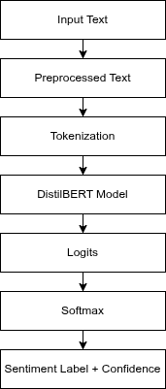
Figure 4 illustrates the sentiment analysis pipeline implemented using a transformer-based model. The preprocessed text is first tokenized using a Hugging Face tokenizer and then passed to a DistilBERT model fine-tuned for sentiment classification. The model outputs logits, which are converted into probability scores using a softmax layer.
Based on these scores, the system determines the sentiment label along with a confidence score. This output is returned to the user interface and also used as metadata for further analysis.

Figure 4: Sentiment Analysis Pipeline

3.5 Embedding Generation and Vector Storage
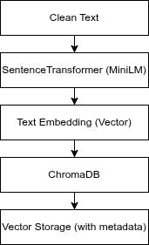
Figure 5 presents the embedding generation process and vector storage workflow. After sentiment prediction, the clean input text is passed to a SentenceTransformer model to generate a dense vector representation. These embeddings capture the semantic meaning of the text.
The generated embeddings, along with associated metadata such as sentiment label and confidence score, are stored in the ChromaDB vector database. This enables efficient similarity-based retrieval during semantic search operations.

Figure 5: Embedding Generation and Vector Database Architecture

3.6 Semantic Search Workflow
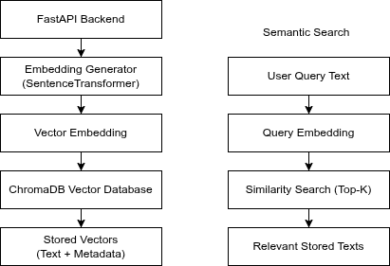
Figure 6: Semantic Search Workflow
Figure 6 illustrates the semantic search mechanism of the system. When a user submits a search query, the query text is converted into an embedding using the same SentenceTransformer model. The query embedding is then compared against stored embeddings in the vector database using similarity metrics.
The system retrieves the top-K most relevant stored texts and returns them to the user interface. This functionality allows users to explore previously analyzed texts that are contextually similar to their input.

4. Implementation
This section explains the implementation details of the system, including data preprocessing, sentiment model inference, embedding generation, vector database integration, and Docker-based deployment. The implementation follows a modular structure to ensure clarity and maintainability.

4.1 Data Preprocessing Implementation
Text preprocessing is implemented to clean and normalize raw user input before it is passed to the machine learning model. The preprocessing logic includes converting text to lowercase, removing URLs and special characters, and normalizing whitespace. These steps help reduce noise and ensure consistent input format for the sentiment analysis model.
The preprocessing functionality is implemented as a separate module, which allows easy reuse and improves code readability. By isolating preprocessing logic, changes to text cleaning rules can be made without affecting other components of the system.

4.2 Sentiment Analysis Model Implementation
The sentiment analysis component is implemented using a pre-trained DistilBERT model fine-tuned on the SST-2 dataset. The model and tokenizer are loaded using the Hugging Face Transformers library. To ensure offline execution, the model is loaded with local file access enabled, relying on a cached version of the model.
During inference, the preprocessed text is tokenized and passed to the DistilBERT model. The model outputs logits, which are converted into probability scores using a softmax function. The sentiment label is determined based on the highest probability, and a confidence score is calculated accordingly. This design ensures both interpretability and reliability of predictions.

4.3 Embedding Generation
After sentiment prediction, the system generates a semantic embedding for the input text. This is implemented using a SentenceTransformer model based on the MiniLM architecture. The embedding generation process converts the input text into a fixed-length dense vector that captures its semantic meaning.
The same embedding model is used for both storing embeddings and processing semantic search queries. This ensures consistency between stored vectors and query vectors, which is essential for accurate similarity-based retrieval.

4.4 Vector Database Integration
ChromaDB is used as the vector database to store and manage text embeddings. Each embedding is stored along with metadata, including the predicted sentiment label and confidence score. This metadata enables richer analysis and filtering of results during retrieval.
When a semantic search request is made, the query text is converted into an embedding and compared with stored embeddings in the database. The system retrieves the top-K most similar vectors based on similarity scores and returns the corresponding text entries to the user interface.

4.5 API and Frontend Communication
The backend of the system is implemented using FastAPI, which exposes a REST endpoint for sentiment prediction. The API receives user input from the frontend, performs preprocessing, sentiment inference, embedding generation, and vector storage, and then returns the prediction results.
The frontend is implemented using Gradio and is responsible for collecting user input and displaying results. The frontend communicates with the backend exclusively through HTTP requests, ensuring a clear separation between user interface logic and machine learning functionality.

4.6 Dockerization and Deployment
The entire application is containerized using Docker and orchestrated with Docker Compose. Each major component runs in a separate container: the FastAPI backend, the Gradio frontend, and the ChromaDB vector database. This separation ensures modularity and simplifies deployment.
To support offline execution, the Hugging Face model cache is mounted as a read-only volume inside the containers. Environment variables are configured to disable online model downloads. This setup ensures that the application can run consistently across different environments without requiring internet access.

4.7 Version Control and GitHub Repository
Version control was maintained throughout the development of this project using Git. All source code, configuration files, and documentation were organized in a structured
Git repository to ensure proper version tracking and reproducibility. The repository follows a clear and modular directory structure, separating application logic, configuration files, and documentation. Meaningful commit messages were used to track incremental changes during development.
The complete project source code is hosted on GitHub and includes all required files such as Python source code, Dockerfile, docker-compose configuration, requirements file, and README documentation. This ensures transparency and allows the project to be easily cloned and executed in different environments.
GitHub Repository Link:
https://github.com/ahtbd/Sentiment-Analysis.git

5. Results and Evaluation
This section presents the results obtained from the implemented sentiment analysis and semantic search system. The evaluation is mainly qualitative and focuses on model predictions, confidence scores, and the effectiveness of embedding-based semantic search, which is a common evaluation approach for transformer-based NLP systems [2][4].

5.1 Sentiment Analysis Results
To evaluate the sentiment analysis component, several text inputs with varying sentiment polarity were tested through the user interface. The system successfully classified user-provided text into positive or negative sentiment categories using a transformer-based model.
Example test cases include:
- Input: “I love this product, it works perfectly.”
Output: Positive sentiment with high confidence.
- Input: “This is the worst service I have ever experienced.”
Output: Negative sentiment with high confidence.
- Input: “The movie was okay, not great but not terrible.”
Output: Predicted sentiment with comparatively lower confidence.
These results are consistent with prior research showing that transformer-based models such as BERT and DistilBERT perform well on clearly opinionated text while showing uncertainty for neutral or ambiguous sentences [2][3].

5.2 Confidence Score Analysis
The confidence score produced by the softmax layer provides an indication of the model’s certainty in its predictions. High confidence values were observed for sentences expressing strong sentiment, whereas sentences with mixed or neutral opinions resulted in lower confidence scores.
This behavior aligns with expected characteristics of neural network classifiers, where probability distributions reflect uncertainty in ambiguous cases [3]. To improve interpretability, low-confidence predictions were treated as uncertain in the user interface, reducing the risk of misleading outputs.

5.3 Semantic Search Evaluation
The semantic search functionality was evaluated by submitting various user queries and retrieving similar stored texts from the vector database. Instead of relying on keyword overlap, the system retrieved semantically related sentences based on embedding similarity.
For example:
- Queries related to poor service quality returned previously stored negative reviews.
- Queries expressing positive experiences retrieved semantically similar positive feedback.
These results demonstrate the effectiveness of sentence-level embeddings for semantic similarity tasks, as discussed in Sentence-BERT literature [4]. The use of a vector database enables efficient similarity search even as the number of stored texts increases [5].

5.4 Performance Considerations
The system demonstrated stable performance during both sentiment inference and semantic search operations. Using pre-trained transformer models allowed efficient inference without additional training overhead. Containerized deployment ensured consistent behavior across environments, which is a known advantage of Docker-based machine learning systems.

Due to the use of a pre-trained model, quantitative accuracy metrics were not computed. Instead, qualitative evaluation was used, which is a common practice when demonstrating applied NLP systems rather than benchmarking models [2].

5.5 Overall Evaluation
Overall, the evaluation results indicate that the system meets its intended objectives. The sentiment analysis component provides reliable predictions with meaningful confidence scores, while the semantic search module enhances analytical capability through context-aware retrieval. The combination of transformer models, vector databases, and Docker-based deployment reflects best practices in modern NLP system design [1][5].

6. Discussion
This section discusses the challenges faced during the development of the system, the benefits of using Docker-based deployment, and the limitations of the current implementation. It also reflects on practical considerations encountered while working with transformer-based NLP models and vector databases.

6.1 Challenges Faced During Implementation
One of the main challenges encountered during this project was handling large transformer models in a resource-constrained environment. Although DistilBERT is a lightweight version of BERT, it still requires careful memory management, especially when running inside Docker containers. To address this issue, the system was designed to run in offline mode using locally cached models, which reduced runtime dependency on external resources.
Another challenge was ensuring smooth communication between multiple services running in separate containers. Proper configuration of Docker networking and service dependencies was required to allow seamless interaction between the user interface, backend API, and vector database. Debugging inter-container communication issues required careful inspection of ports, service names, and environment variables.

6.2 Offline Model Execution and Reproducibility
Running transformer models in offline mode presented both challenges and benefits. Initially, setting up offline execution required correct configuration of model cache paths and environment variables. However, once configured, this approach significantly improved reproducibility and stability.
Offline execution ensures that the system behaves consistently across different environments, as model versions remain fixed and external changes do not affect the application. This design choice aligns with best practices in machine learning deployment, where reproducibility is considered a critical requirement [2][3].

6.3 Benefits of Docker-Based Deployment
Docker played a crucial role in simplifying deployment and ensuring consistency across development and execution environments. By containerizing each major component of the system, dependency conflicts were avoided, and the overall setup became easier to manage.
The use of Docker Compose allowed the orchestration of multiple services with minimal configuration. Each service was isolated yet connected through a shared network, enabling a clean microservice architecture. Such container-based deployment strategies are widely adopted in modern machine learning systems due to their scalability and portability [1].

6.4 Limitations of the System
Despite its successful implementation, the system has several limitations. First, the sentiment analysis model is used in its pre-trained form without task-specific fine-tuning. While this approach simplifies implementation, fine-tuning on a domain-specific dataset could further improve performance.
Second, the evaluation of the system is primarily qualitative. Although this is acceptable for demonstrating system functionality, quantitative evaluation metrics such as accuracy or F1-score could provide deeper insights into model performance.
Finally, the current system focuses on binary sentiment classification. More complex sentiment categories or multilingual support are not addressed in this implementation.

6.5 Discussion Summary
Overall, the challenges faced during development provided valuable practical experience in deploying transformer-based NLP systems. The combination of offline execution, vector databases, and Docker-based deployment demonstrates a realistic and industry-relevant approach to building modern NLP applications. Despite certain limitations, the system fulfills its intended objectives and provides a strong foundation for future enhancements.

7. Conclusion & Future Work
This project successfully demonstrated the design and implementation of a Dockerized transformer-based sentiment analysis and semantic search system. The system integrates modern NLP techniques, deep learning models, vector databases, and containerized deployment into a cohesive and functional application.
A pre-trained DistilBERT model was used to perform sentiment classification, providing reliable predictions along with confidence scores. In addition, semantic search functionality was implemented using sentence embeddings and a vector database, allowing the system to retrieve contextually similar past texts. The use of a microservice architecture ensured clear separation between the user interface, backend inference logic, and vector storage components.
Docker-based deployment played a key role in ensuring reproducibility, portability, and consistency across environments. By running the system in offline mode after initial model caching, dependency on external services was minimized, making the application more stable and suitable for real-world deployment scenarios. Overall, the project meets the objectives defined in the course guidelines and demonstrates practical understanding of transformer-based NLP systems.

7.1 Future Work
Although the current implementation fulfills its intended goals, several improvements can be considered for future development. First, the sentiment analysis model could be fine-tuned on a domain-specific dataset to improve classification accuracy for specific use cases such as product reviews or social media content.
Second, the system could be extended to support additional sentiment categories or multilingual input, enabling broader applicability. Incorporating quantitative evaluation metrics such as accuracy, precision, recall, and F1-score would also provide deeper insight into model performance.
Finally, the semantic search component could be further enhanced by experimenting with alternative embedding models or integrating retrieval-augmented generation techniques. These extensions would make the system more robust and align it with advanced NLP applications currently used in industry and research [1][2].

REFERENCES
Below is the complete reference list used across all four report parts:
[1] Vaswani, A., Shazeer, N., Parmar, N., Uszkoreit, J., Jones, L., Gomez, A. N., Kaiser, Ł., & Polosukhin, I. (2017). Attention Is All You Need. Advances in Neural Information Processing Systems (NeurIPS).
[2] Devlin, J., Chang, M. W., Lee, K., & Toutanova, K. (2019). BERT: Pre-training of Deep Bidirectional Transformers for Language Understanding. Proceedings of the 2019 Conference of the North American Chapter of the Association for Computational Linguistics (NAACL-HLT).
[3] Sanh, V., Debut, L., Chaumond, J., & Wolf, T. (2019). DistilBERT, a Distilled Version of BERT: Smaller, Faster, Cheaper and Lighter. NeurIPS Workshop on Energy Efficient Machine Learning.
[4] Reimers, N., & Gurevych, I. (2019). Sentence-BERT: Sentence Embeddings using Siamese BERT-Networks. Proceedings of the 2019 Conference on Empirical Methods in Natural Language Processing (EMNLP).
[5] Merkel, D. (2014). Docker: Lightweight Linux Containers for Consistent Development and Deployment. Linux Journal, 2014(239).
[6] ChromaDB Documentation. (2023). Retrieved from https://www.trychroma.com

